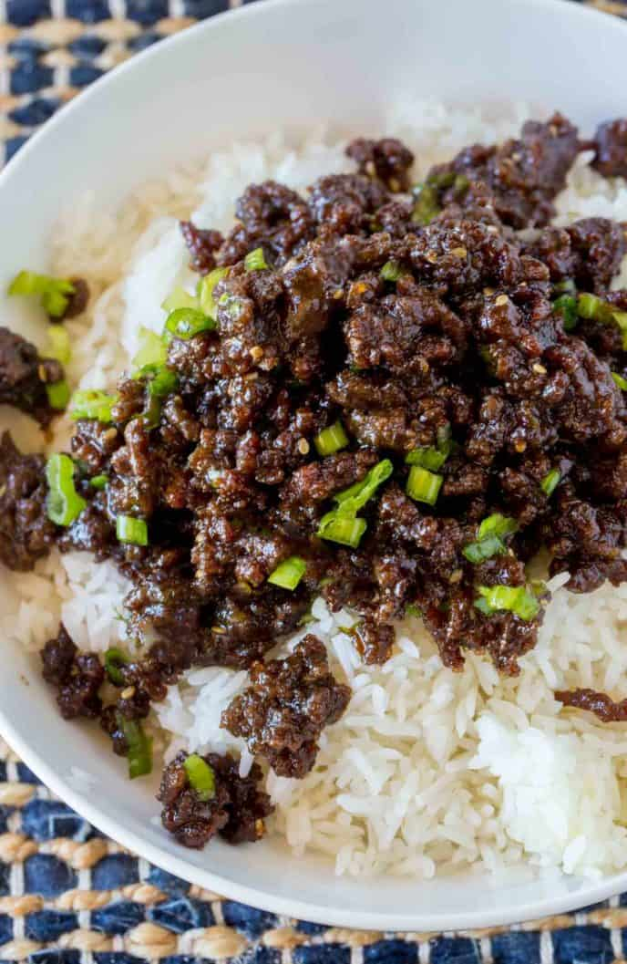
Korean Ground Beef
Prep time 10 min Cook time 10 min
4 Servings
Ingredients
1 lb lean ground beef
1 tbsp sesame oil
3 cloves garlic minced
1 tsp fresh ginger minced
½ cup brown sugar
¼ cup lite soy sauce
2 tsp sriracha
Directions
- Heat a large pan over medium high heat.
- Brown the meat with sesame oil, garlic and ginger.
- Drain the fat, add brown sugar, soy sauce, and Sriracha.
- Cook until the liquid has re-absorbed and the meat is shiny but not soupy.
- Serve over rice and top with green onions.
Notes
If you don’t have fresh garlic or ginger, use ½ teaspoon of ground garlic and ½ teaspoon of ground ginger in its place.
You can have an even deeper flavor with dark brown sugar.
Add a little to the ground beef when reheating as needed.

